Matthew W. Leigh

mwleigh@ranken.edu

Abstract

Initial setup of a MicroLogix 1100 PLC and procedure required to re-instate a preconfigured IP address.

MicroLogix 1100

Communications Setup

Table of Contents

Hardware Connections 1

Communications Presets 2

Command Prompt 4

IP Address Discovery 5

MAC Address Discovery 6

BOOTP Server 7

BOOTP Server Configuration 8

Assign IP to MAC 9

Enable BOOTP 11

Check PLC IP 12

Save Boot Configuration 13

Restore IP Configuration 14

Restore PLC IP 15

# Hardware Connections

Connect an Ethernet cable from your PC to the MicroLogix 1100 programmable logic controller.

|  |  |
| --- | --- |
|  |  |

Power-up the MicroLogix 1100.

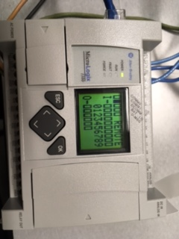

The square under **COMM1** should be filled-in.

# Communications Presets

Ensure that your PC’s wireless system is turned **off** by pressing the  button.

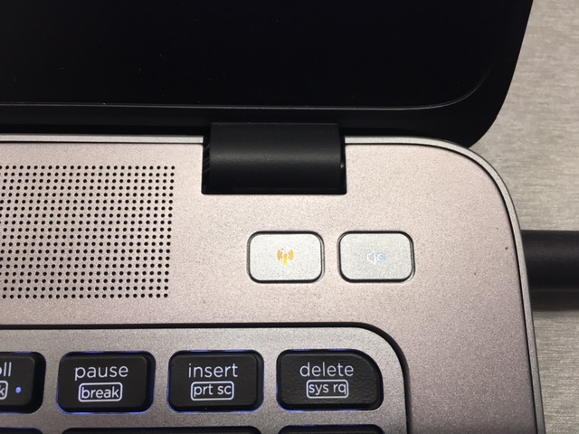

The wireless symbol on the button shall change to orange when it is off.

## Command Prompt

From your Window desktop type **cmd** in the *‘Search the web and Windows’* input in the lower left corner of your monitor.

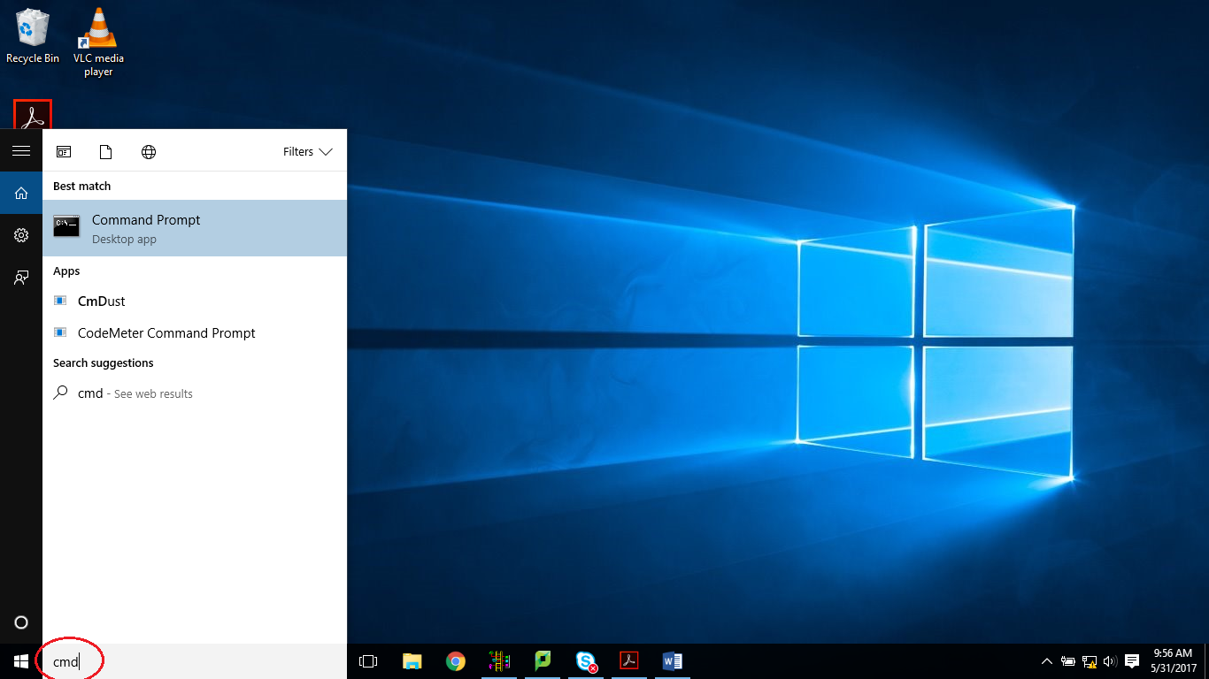

This will open the *Command Window* where you will be able to enter MS-DOS commands. (MS-DOS stands for Microsoft - Disk Operating System). Type in the command **ipconfig** and hit [Enter].

## IP Address Discovery

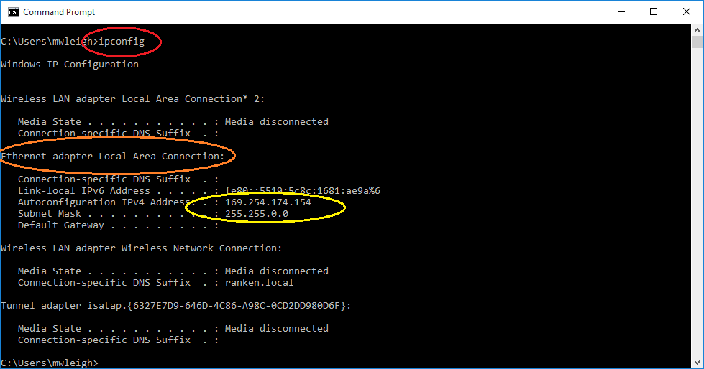

The red circle indicates the command entered. The remainder of the screen text is the resulting report generated by the command. Observe the report and look for the information regarding the *‘Ethernet adapter Local Area Connection’* (seen above in the orange circle). This is the information that pertains to the Ethernet port on the side of your notebook PC. Record the *IPv4 Address* and the *Subnet Mask* (your IPv4 Address and possibly the Subnet mask shall be different than that above in the yellow circle)

## MAC Address Discovery

On the MicroLogix 1100, press the [ESC] button to exit the status screen and return to the menu options. Press the down arrow on the front of the MicroLogix 1100 until you are pointed to the **Advance Set** and press [OK]. Press the down arrow until the **ENET Cfg** is selected and press [OK].

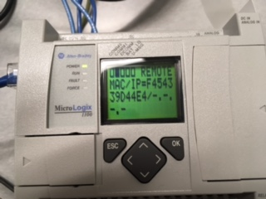

Record the MAC address. MAC stands for Media Access Control address and is used for network addressing including Ethernet and Wireless addressing. It is unique to each specific network card, so most likely yours shall be different from that shown above. Record your specific MAC address. The PLC does not have an IP address yet. That will be our next step.

# BOOTP Server

From your Window desktop type **BOOTP** in the *‘Search the web and Windows’* input in the lower left corner of your monitor.

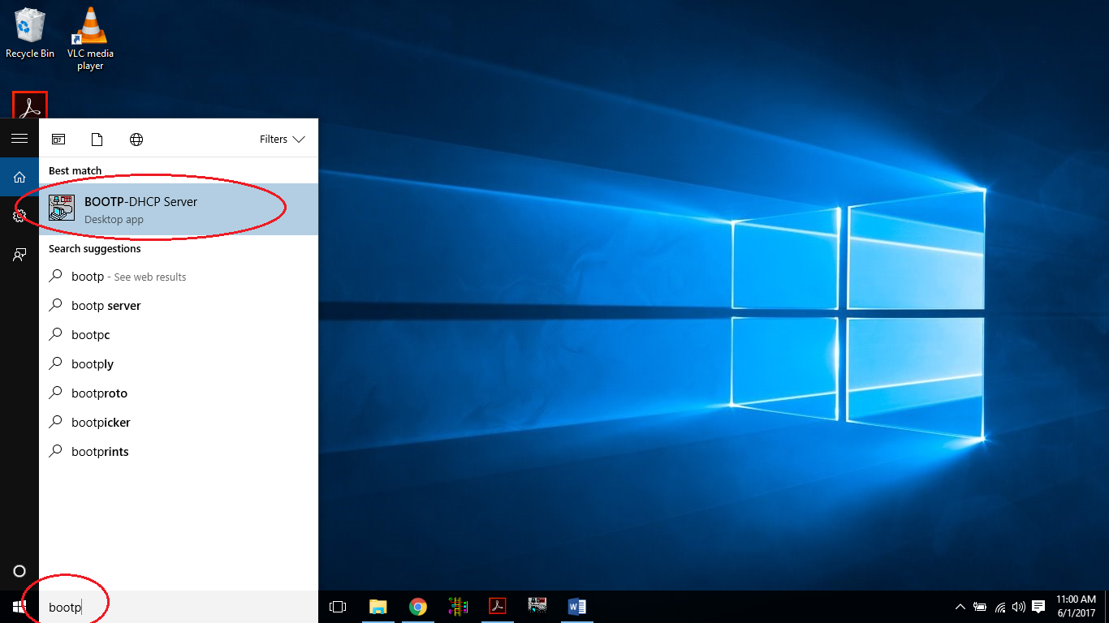

Select the BOOTP-DHCP Server Desktop app.

## BOOTP Server Configuration

This will open a window like that shown below. Locate the PLC’s MAC address in the upper window.

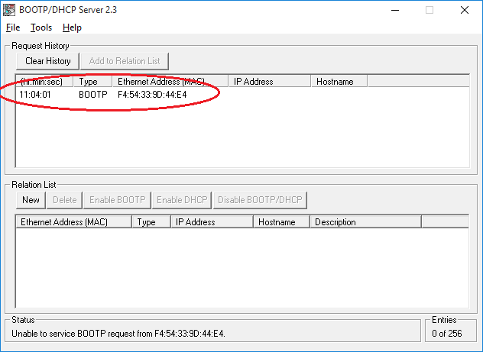

### Assign IP to MAC

Select your MAC address and press [Add to Relation List].

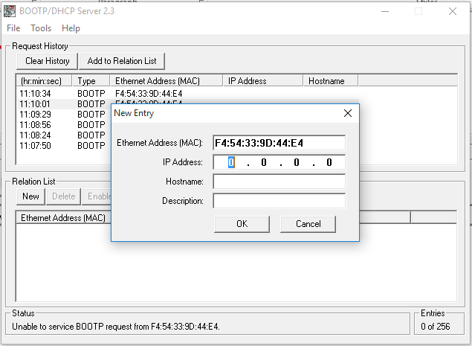

Here we will enter an IP (which stands for Internet Protocol) address for the PLC. An IPv4 address is made up of four octets separated by ‘dots’. Each octet can be a number between 0 and 255. Referring to your PC’s IP address that you record early, enter the first three octets into the **IP Address** field and make the fourth octet any value between 0-255 that is **not** that same as your PC’s fourth octet. Enter a **Hostname** that begins with “ML” for MicroLogix and ends with two numbers and a letter that corresponds to the label on your MicroLogix PLC. So if your PLC has a label 2A, your host name would be *ML02A*. The corresponding **Description** would be *MicroLogix 1100 PLC 02A*.

Below is the completed screen.

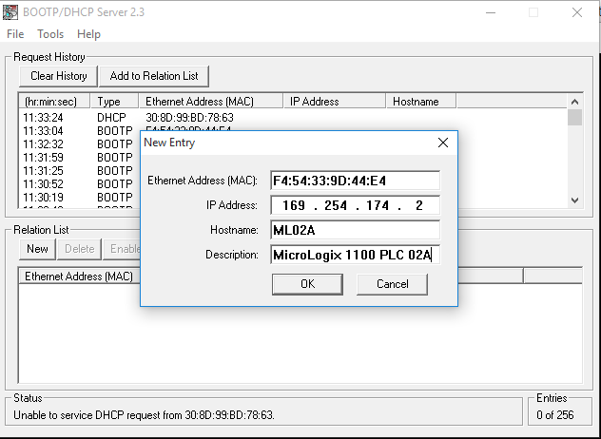

## Enable BOOTP

Ensure that your PC’s wireless is still off. Highlight your PLC in the **Relation List** and press the [Enable BOOTP]. This will take little while to complete.

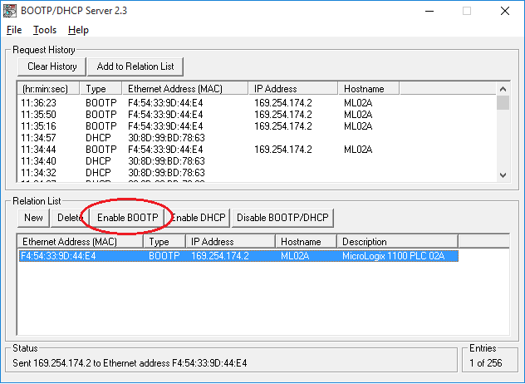

# Check PLC IP

Once complete, your PLC will display your related IP address.

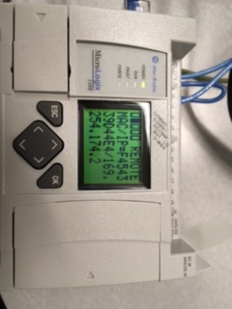

# Save Boot Configuration

Save your boot configuration to be used at a later date.

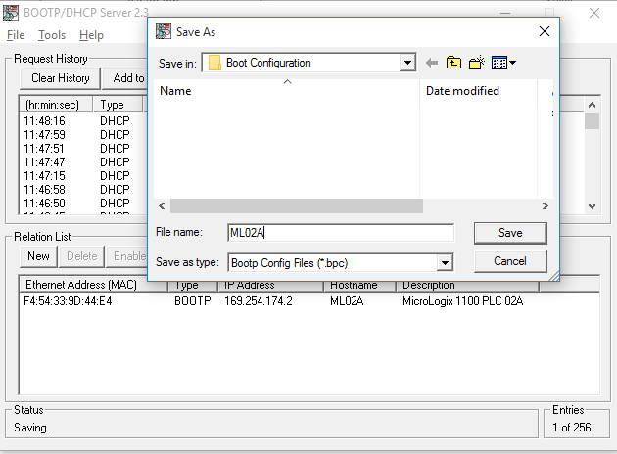

# Driver Setup

From your Window desktop type **Classic** in the *‘Search the web and Windows’* input in the lower left corner of your monitor.

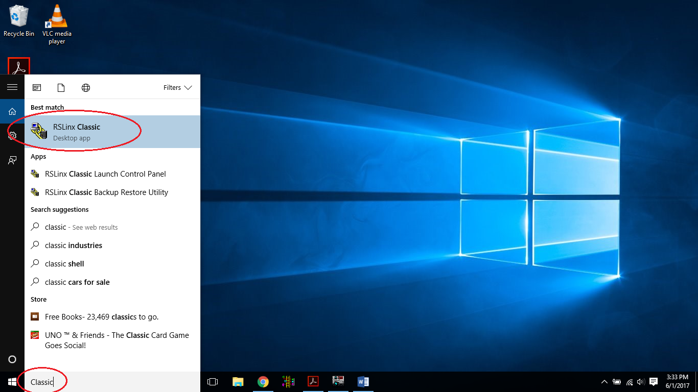

Select the RSLinx Classic Desktop application.

## RSWho

Select *Communications* then *RSWho*.

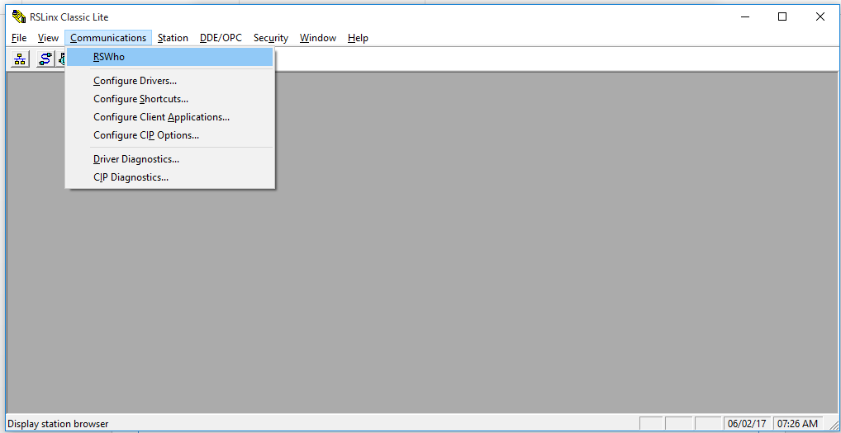

## RSWho Results

Select the AB_ETHP_2, Ethernet card. This is the network interface card (NIC) on the side of your PC. A list of IP addresses will show that have red Xs over them. Those where previously connected devices that are currently unreachable. In the status bar a message should be displayed that states

***Browsing – node xxx.xxx.xxx.xxx found***

where the Xs will correspond to your PLC’s IP address. Communication is established. Nothing further needs to be done. You may close RSLinx Classic.

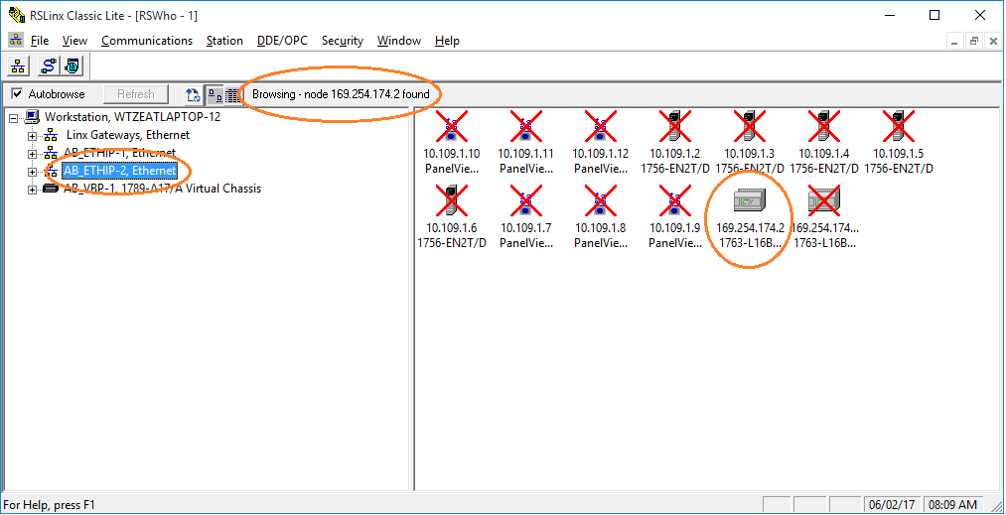

# RSLogix 500

From your Window desktop type **RSLogix** in the *‘Search the web and Windows’* input in the lower left corner of your monitor.

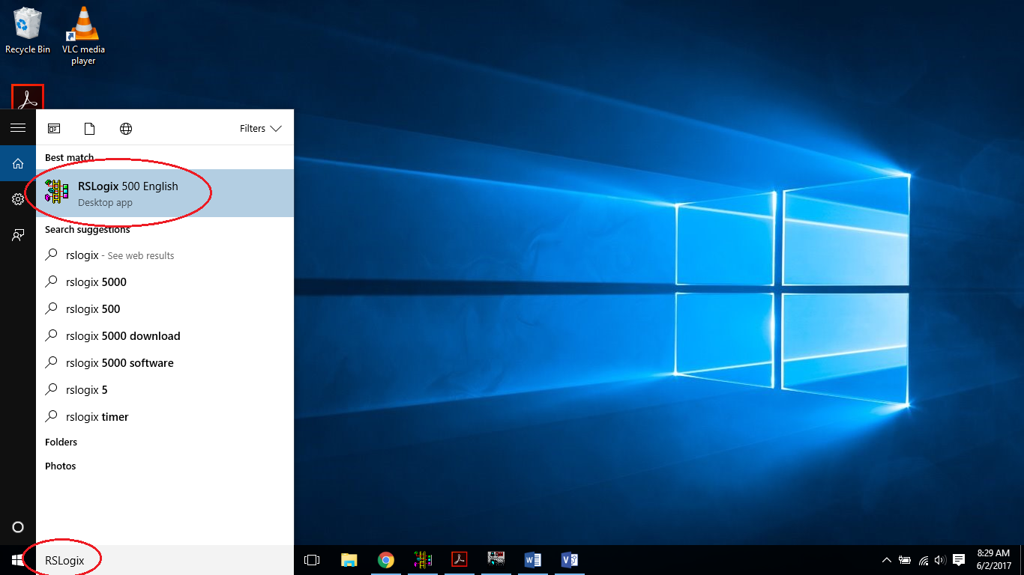

## RXLogix Who Active Go Online

Select *Comms* then *Who Active Go Online.*

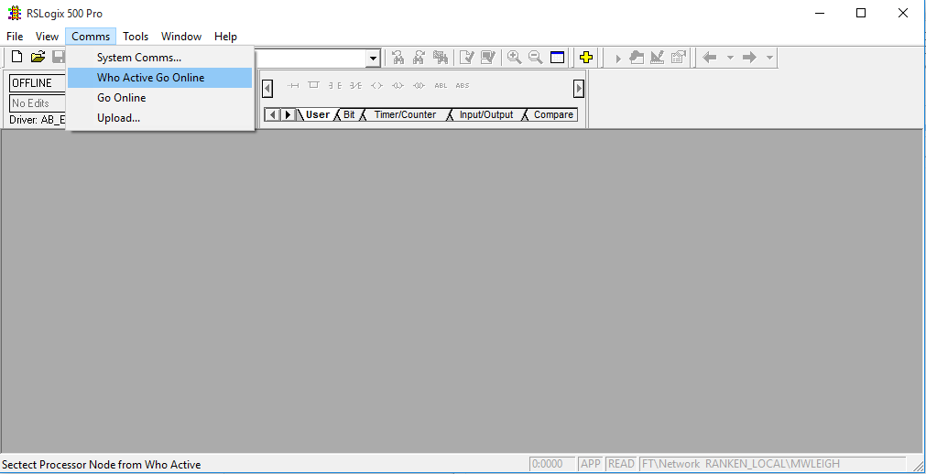

## RSLogix 500 Communications

Below is the result of the Comms .> Who Active Go Online

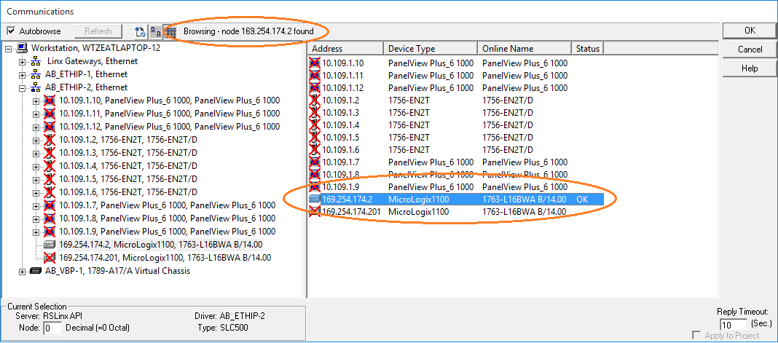

Look for your PLC’s address. It should not have a red X in it’s icon. Select your PLC’s address in the right window pane and press [OK].

### Going to Online Programming State

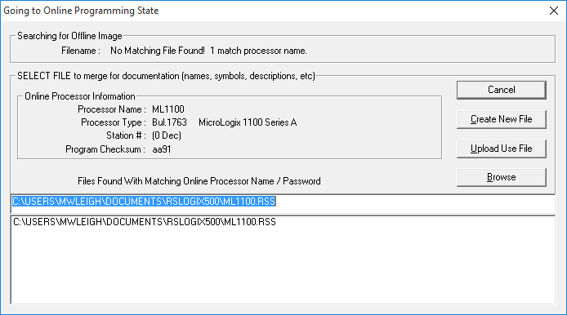

Select [Create New File].

# RSLogix 500 New Program

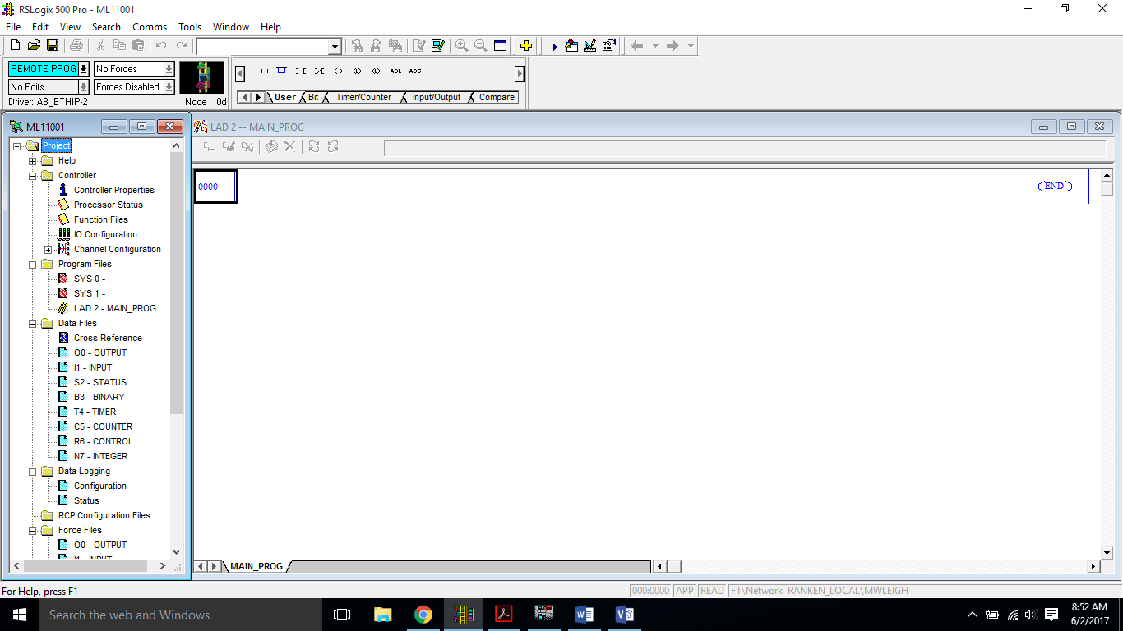

You may now begin programming.

# Restore IP Configuration

Perform the following steps described earlier in the document;

1. Connect PC to PLC
2. Disable Wireless
3. Power-up PLC
4. Open BOOTP Server
5. Open previously saved Configuration file

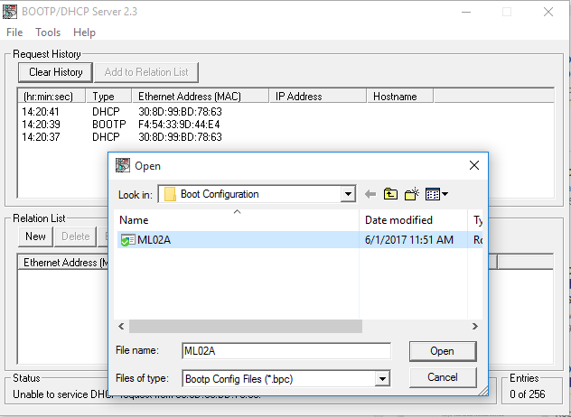

## Restore PLC IP

Once the configuration file is open, the server will establish communications with the PLC (via the MAC address) and assign the IP address configured in the Relation List. You **do not** need to select your controller in the Relation List and enable BootP again. The BOOTP Server is designed to “serve-up” all the IPs in it’s Relation List, but since we only have one PLC in the configuration file, it’s task is quite simple.

